STAUER PUBLISHING
Bøger og kulturarrangementer | Books and cultural events
www.stauer-publishing.dk
stauerpublishing@gmail.com | +45 40592283 (Jens Staubrand)

october 2024
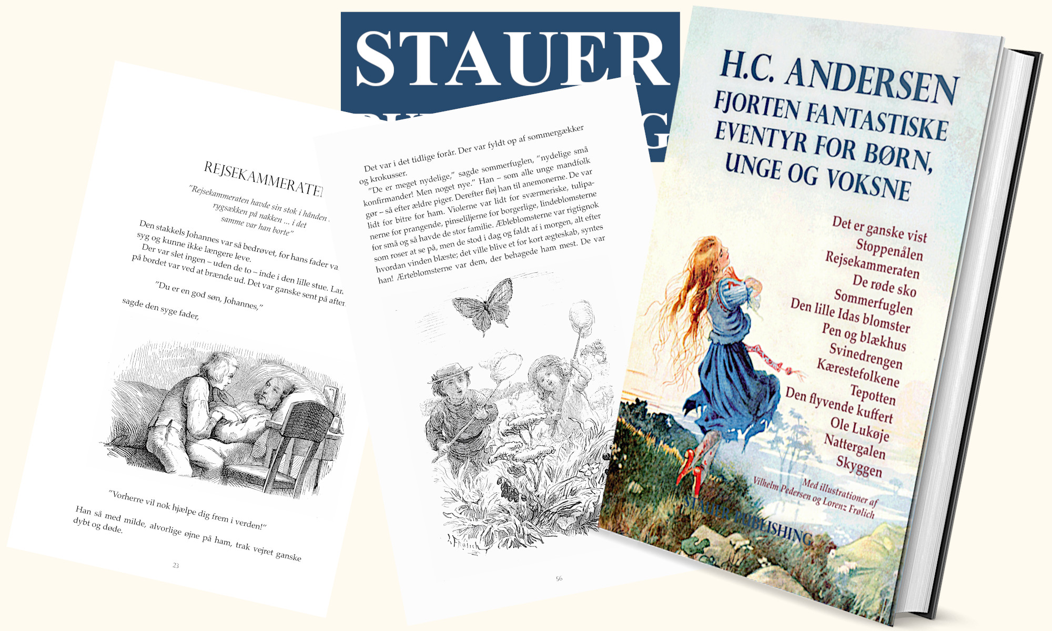
The press release is available in Word on our site | Press photos in the same place
​
PRESS RELEASE | H.C. Andersen's timeless adventure is resurrected
in new release – Fourteen fantastic adventures for children, young people and adults

​One of Denmark's most beloved authors, H.C. Andersen, gets new life in a lovely book publication, Fourteen fantastic adventures for children, young people and adults. This collection, consisting of fourteen of H.C. Andersen's most iconic and adventurous stories – selected and edited by mag.art. Jens Staubrand – give both old and new readers the opportunity to experience the magic and depth of his writing.

The book is aimed at both children, young people and adults and is a unique bridge building between generations that everyone can immerse themselves in H.C. Andersen's universe.

A treasure trove of adventures for all ages

Fourteen Fantastic Adventures features some of H.C. Andersen's best-known fairy tales such as The Red Shoes, The Nightingale, The Darting Needle and Little Ida's Flowers. These stories are not only part of Denmark's literary heritage, but also universal stories that have inspired and moved people around the world. In this publication, the adventures are presented in a new editing who preserves the original spirit, while at the same time making them accessible and relevant to a contemporary reader.

A timeless language that speaks to both children and adults

It is a philosopher, mag.art. Jens Staubrand who has selected the adventurers for children, young people and adults. With hisediting, which ensures easy-to-understand and fluent language, this book offers both new and experienced readers an introduction to H.C. Andersen's magical world. The depth and morals of the fairy tales are still at the center, and readers are led into stories that not only entertain, but also provoke reflection on human values, which fall directly into contemporary questions of identity, courage and vulnerability.

An unforgettable journey through H.C. Andersen's universe

Fourteen fantastic adventures distinguish themselves by embracing both the well-known and lesser-known tales. From the iconic story of the Nightingale, which deals with nature and technology, to the thought-provoking Shadow, which delves into the question of identity and existence, the book offers a wealth of adventures that range widely from the bright and optimistic to the dark and philosophical .

This collection is a treasure trove for those who wish to rediscover Andersen's masterpieces and for those who have yet to delve into his alluring universe.

A book for generations

Fourteen fantastic adventures for children, young people and adults are more than just a collection of fairy tales. It is a tribute to H.C. Andersen and his ability to connect generations through stories that speak to both the heart and the mind. Whether the book is read aloud to children, or whether adults immerse themselves in the underlying philosophical layers, this publication creates a space for shared reflection and experience.

Illustrations

The book's illustrations are by Vilhelm Pedersen and Lorenz Frølich. The children and young people who have not seen them before will hopefully find them beautiful, thought-provoking and illustrative, and the adult reader - who of course knows them - will hopefully be delighted to see them again. The book's cover is a reproduction of Honor Charlotte Appleton's illustration for H.C. Andersen's ”The Red Shoes”.

BUY worldwide in store or online

H.C. ANDERSEN Fourteen fantastic adventures for children, young people and adults [the book is in Danish]
It is, of course, The Darting Needle, The Traveling Companion, The Red Shoes, The Butterfly, Little Ida's Flowers, Pen and Inkhouse, The Pigboy, The Lovers, The Teapot, The flying suitcase, Ole Lukøye, the Nightingale, the Shadow.
With illustrations by Vilhelm Pedersen and Lorenz Frølich
ISBN 9788792510754

Sincerely, Stauer Publishing
STAUER PUBLISHING, Svanholmsvej 10, DK-1905 Frederiksberg C, Phone +45 40 59 22 83 (Jens Staubrand), stauerpublishing@gmail.com, www.stauer-publishing.dk, cvr-nr.: 36204060, Bank: 6610 0002540744, IBAN DK8166100002540744, BIC/SWIFT JYBADKKK

