STAUER PUBLISHING
Bøger og kulturarrangementer | Books and cultural events
www.stauer-publishing.dk
stauerpublishing@gmail.com | +45 40592283 (Jens Staubrand)

maj 2023
The press release is available in Word on our site | Press photo in the same place

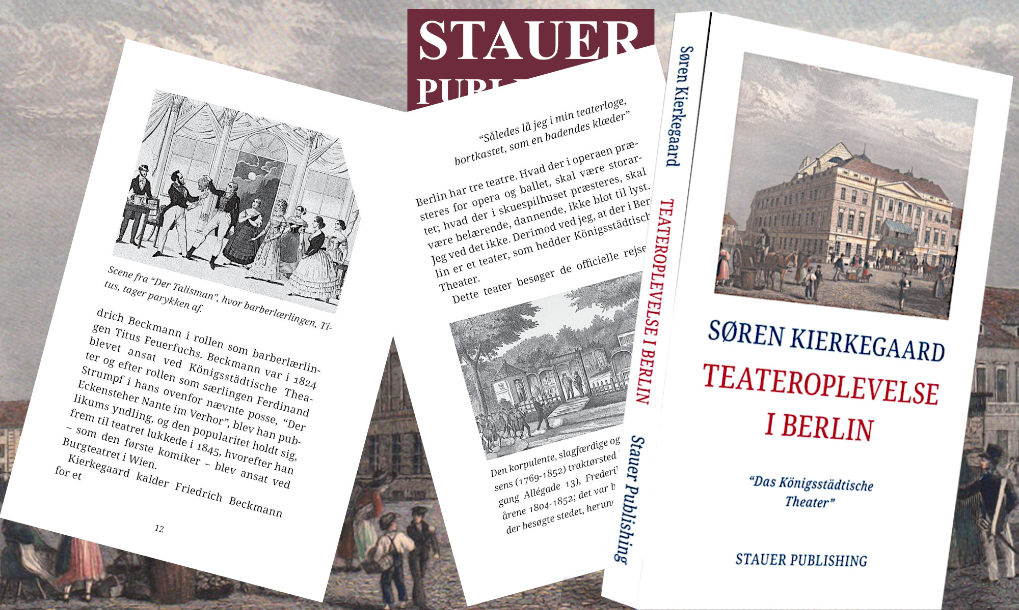

PRESS RELEASE | New publication: Søren Kierkegaard's theatre experience in Berlin – Das Königsstädtische Theater

The publisher Stauer Publishing hereby presents the Søren Kierkegaard book: Theatre experience in Berlin “Das Königsstädtische Theater”, edited by mag.art. Jens Staubrand.

The private theatre Das Königsstädtische Theater was located on the corner of Alexanderplatz and Alexanderstrasse and was, in the first half of the nineteenth century, a real magnet for the broad masses of the population. Farces, melodramas, vaudevilles and operas were performed here.

In the short essay we hear about Søren Kierkegaard's observation of another theatergoer, a young girl, as well as his experience of the popular play "The Talisman" at the time, which is about the difficulties that the play's protagonist, the barber's apprentice Titus, played by the then-famous actor Friedrich Beckmann, who, being red-haired, has, according to the standards of the time, to be able to manage both in work and love life and therefore has to wear a wig to hide his red hair, but who in the end, with his red hair, wins both love and a lot of money.

The book should interest everyone who wants to gain insight into the cultural landscape that shaped one of Denmark's greatest philosophers.

The book - which is illustrated - has been edited and commented on by author and philosopher, mag.art. Jens Staubrand.

BUY worldwide in store or online

SØREN KIERKEGAARD ​​Teateroplevelse i Berlin [Theater experience in Berlin - the book is in Danish]
”Das Königsstädtische Theater”
The book is illustrated and annotated
ISBN 9788792510631

Best regards

Stauer Publishing | www.stauer-publishing.dk
​stauerpublishing@gmail.com | M +45 40 59 22 83 (Jens Staubrand)

STAUER PUBLISHING, Svanholmsvej 10, DK-1905 Frederiksberg C, Phone +45 40 59 22 83 (Jens Staubrand), stauerpublishing@gmail.com, www.stauer-publishing.dk, cvr-nr.: 36204060, Bank: 6610 0002540744, IBAN DK8166100002540744, BIC/SWIFT JYBADKKK

