STAUER PUBLISHING
Bøger og kulturarrangementer | Books and cultural events
www.stauer-publishing.dk
stauerpublishing@gmail.com | +45 40592283 (Jens Staubrand)

august 2024

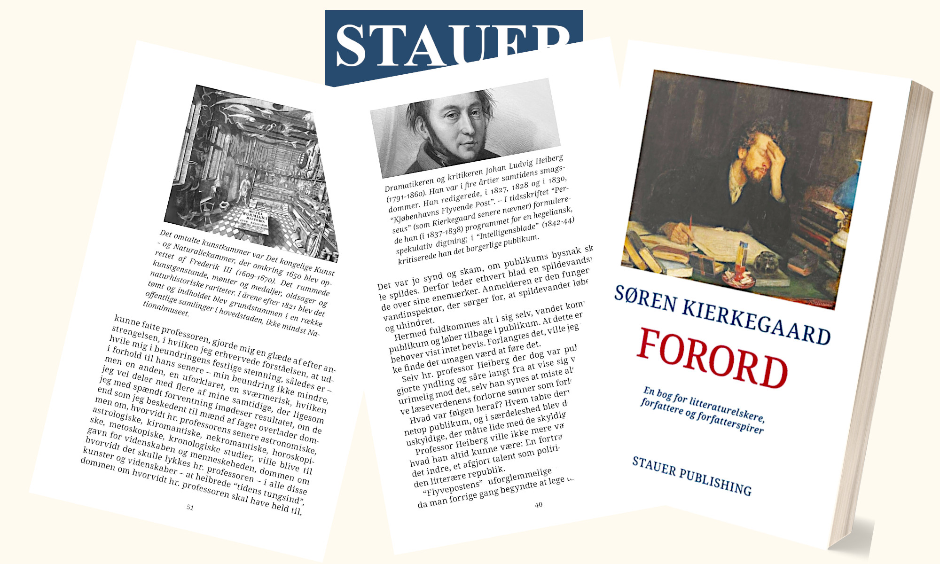

The press release is available in Word on our site | Press photo in the same place

PRESS RELEASE | Stauer Publishing launches 3rd edition of Søren Kierkegaard's "Preface" – edited by philosopher Jens Staubrand

Stauer Publishing is proud to present the 3rd edition of Søren Kierkegaard's "Preface", edited and annotated by author and philosopher, mag.art. Staubrand.

This edition has been praised for its approach to Søren Kierkegaard's satirical and deeply ironic text, which was first published in 1844 under the pseudonym Nicolaus Notabene.

Jens Staubrand's editing makes the work accessible to modern readers and opens the door to Søren Kierkegaard's sharp, humorous criticism of the role of the author, the vanity of writing and the culture of prefaces in literature.

This 3rd edition comes as a response to the work's growing popularity and importance, emphasizing the relevance of Søren Kierkegaard's thoughts in our own time.

Through Jens Staubrand's editing and notes, readers gain insight into Søren Kierkegaard's challenging thoughts on vanity, existence and art.

With this edition, Stauer Publishing offers a reading experience that combines intellectual depth and humorous sharpness, which appeals to both philosophy enthusiasts and general readers.

Kind regards

Stauer Publishing | www.stauer-publishing.dk
stauerpublishing@gmail.com | M +45 40 59 22 83 (Jens Staubrand)

STAUER PUBLISHING, Svanholmsvej 10, DK-1905 Frederiksberg C, Phone +45 40 59 22 83 (Jens Staubrand), stauerpublishing@gmail.com, www.stauer-publishing.dk, cvr-nr.: 36204060, Bank: 6610 0002540744, IBAN DK8166100002540744, BIC/SWIFT JYBADKKK

