STAUER PUBLISHING
Bøger og kulturarrangementer | Books and cultural events
www.stauer-publishing.dk
stauerpublishing@gmail.com | +45 40592283 (Jens Staubrand)

november 2022
The press release is available in Word on our site | Press photo in the same place

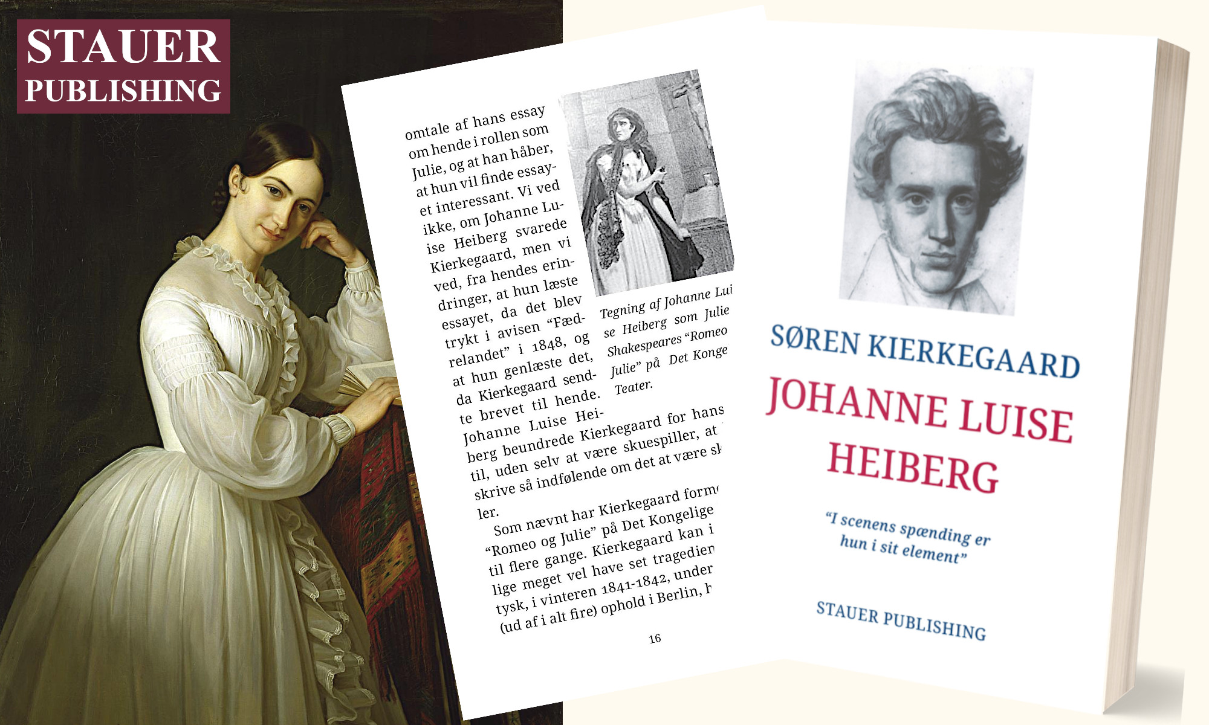

PRESS RELEASE | Søren Kierkegaard's "The Crisis and a Crisis in an Actress' Life" and Johanne Luise Heiberg as Julie

Johanne Luise Heiberg (1812-1890), one of the leading actresses of her time, was given the surname Heiberg when, in 1831, at the age of nineteen, she married the writer and critic Johan Ludvig Heiberg, who was just over twenty years her senior.

Before her marriage, her name was Johanne Luise Pätges, and it was under that name that in the autumn of 1828, at the age of sixteen, she first played Juliet in William Shakespeare's (1564-1616) tragedy "Romeo and Juliet", which takes place in Italy and is about a young couple who are not allowed to have each other because they belong to rival noble families - and who both commit suicide.

The performance was a resounding success. Both the audience and the critics were enthusiastic.

In January 1847, almost twenty years later, she again played – successfully – the role of Julie, and it was on this occasion that Søren Kierkegaard (1813-1855) wrote his dramatic-philosophical essay about Johanne Luise Heiberg, whose original title is “The Crisis and a Crisis in the Life of an Actress”.

The following year it was published in the newspaper “Fædrelandet”.

Søren Kierkegaard’s essay is a tribute to Johanne Luise Heiberg’s ability as an actress.

SØREN KIERKEGAARD ​​Johanne Luise Heiberg [The actress Johanne Luise Heiberg - the book is in Danish]
”In the excitement of the stage she is in her element”
The book is illustrated and annotated
ISBN 9788792510549

Best regards

Stauer Publishing | www.stauer-publishing.dk
​stauerpublishing@gmail.com | M +45 40 59 22 83 (Jens Staubrand)

STAUER PUBLISHING, Svanholmsvej 10, DK-1905 Frederiksberg C, Phone +45 40 59 22 83 (Jens Staubrand), stauerpublishing@gmail.com, www.stauer-publishing.dk, cvr-nr.: 36204060, Bank: 6610 0002540744, IBAN DK8166100002540744, BIC/SWIFT JYBADKKK

