STAUER PUBLISHING
Bøger og kulturarrangementer | Books and cultural events
www.stauer-publishing.dk
stauerpublishing@gmail.com | +45 40592283 (Jens Staubrand)

juli 2024

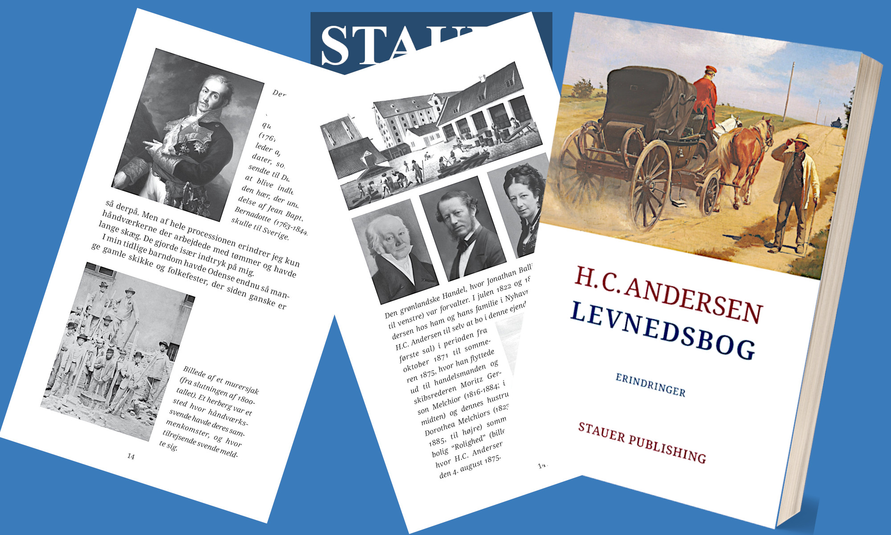
The press release is available in Word on our site | Press photo in the same place

PRESS RELEASE | Experience a moving portrait of an artist who
never let the limitations of time stop him

Now the 2nd edition of H.C. Andersen's Biography – An insight into the fairy tale writer's own life.

Stauer Publishing is pleased to present the 2nd edition of H.C. Andersen's fascinating Biography, edited by author and philosopher, mag.art. Jens Staubrand, who has also selected the book's images and written comments on them.

This rare and personal depiction of the great Danish author's early life gives readers a unique insight into H.C. Andersen's childhood and youth, his longing for artistic recognition and his first encounters with the literary world.

H.C. Andersen's Biography provides a unique insight into the fairy tale writer's early life and journey towards becoming one of the world's most beloved authors. In his own words, H.C. Andersen takes the reader on a journey through his childhood in Odense, dreams and ambitions, and the challenges he had to overcome to make his name in the world of literature.

With this publication of Life, Stauer Publishing offers a valuable document that provides a deep and personal insight into H.C. Andersen as a person and artist.

The book makes it possible for contemporary readers to understand how H.C. Andersen's life and experiences became the inspiration for his fairy tales and stories, which have touched people all over the world.

Jens Staubrand's editing makes Life accessible to both new readers and those who are already familiar with H.C. Andersen's writings.

Buy worldwide in stores or online

H.C. ANDERSEN Levnedsbog [Autobiography – the book is in Danish]
Memories
The book is illustrated and annotated
ISBN 9788792510525
Now 2nd edition
PRICE 325 DKK

Best regards

Stauer Publishing | www.stauer-publishing.dk ​
stauerpublishing@gmail.com | M +45 40 59 22 83 (Jens Staubrand)

STAUER PUBLISHING, Svanholmsvej 10, DK-1905 Frederiksberg C, Phone +45 40 59 22 83 (Jens Staubrand), stauerpublishing@gmail.com, www.stauer-publishing.dk, cvr-nr.: 36204060, Bank: 6610 0002540744, IBAN DK8166100002540744, BIC/SWIFT JYBADKKK

