STAUER PUBLISHING
Bøger og kulturarrangementer | Books and cultural events
www.stauer-publishing.dk
stauerpublishing@gmail.com | +45 40592283 (Jens Staubrand)

januar 2024

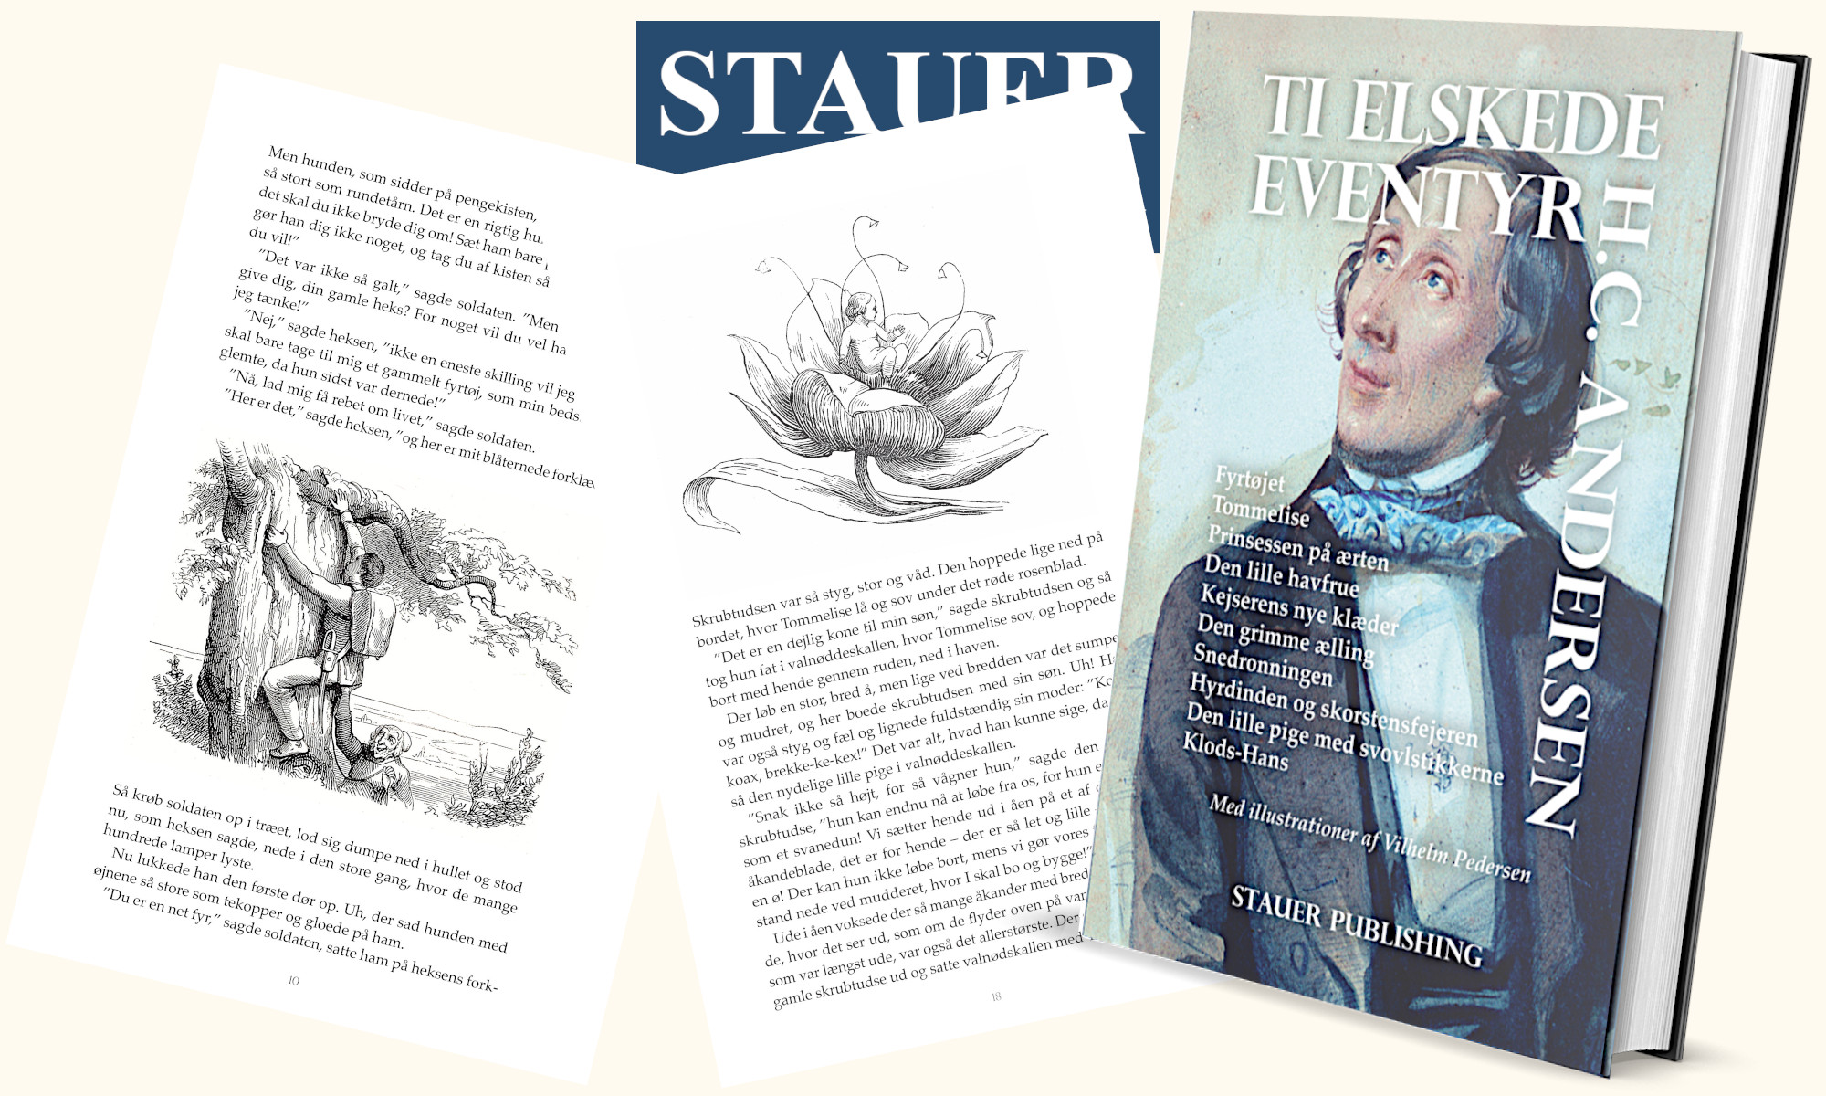

The press release is available in Word on our site | Press photo in the same place

PRESS RELEASE

New publication from Stauer Publishing: H.C. Andersen's "Ten Beloved Fairy Tales" – A collection of Denmark's most beloved tales, edited by Jens Staubrand

Stauer Publishing is pleased to present a new, beautifully illustrated edition of H.C. Andersen's "Ten Beloved Fairy Tales", edited by author and philosopher, mag.art. Jens Staubrand.

This special edition collects some of H.C. Andersen's most iconic and timeless tales, including "The Little Mermaid", "The Ugly Duckling", "The Emperor's New Clothes" and many more, which have fascinated both children and adults for generations.

"Ten Beloved Fairy Tales" is a book that brings together H.C. Andersen's magical universe in an edition that appeals to both new readers and those who have loved the fairy tales for many years.

With Jens Staubrand's editing, this edition of the fairy tale collection is a valuable addition to any home and an obvious gift for readers of all ages.

H.C. ANDERSEN Ten beloved fairy tales [the book is in Danish]

The Firecracker, Thumbelina, The Princess and the Pea, The Little Mermaid, The Emperor's New Clothes, The Ugly Duckling, The Snow Queen, The Shepherdess and the Chimney Sweep, The Little Match Girl, Hansel and Gretel
With illustrations by Vilhelm Pedersen

ISBN 9788792510747

Best regards

Stauer Publishing | www.stauer-publishing.dk
​stauerpublishing@gmail.com | M +45 40 59 22 83 (Jens Staubrand)

STAUER PUBLISHING, Svanholmsvej 10, DK-1905 Frederiksberg C, Phone +45 40 59 22 83 (Jens Staubrand), stauerpublishing@gmail.com, www.stauer-publishing.dk, cvr-nr.: 36204060, Bank: 6610 0002540744, IBAN DK8166100002540744, BIC/SWIFT JYBADKKK

